**Debugging in DrRacket**

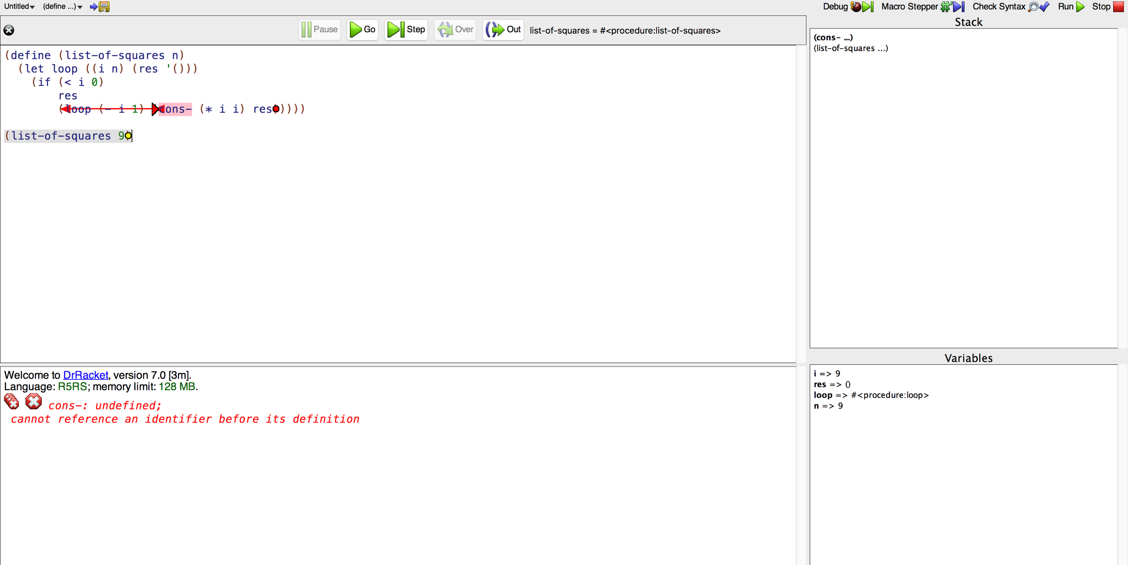

* **Debug** lets users control and observe the program as it executes.
* **Pause** will interrupt execution and pause it.
* **Go** resumes until it either completes, reaches a breakpoint, or raises an exception.
* **Step** button makes a single step and then pause again.
* When **Over** button is enabled, it sets a one-time breakpoint at the end of the expression marked by a green circle and causes the program to proceed until it reaches the breakpoint. Then, it pauses and removes that breakpoint.
* **Out** button is enabled when an expression is within another expression. Like the Over button, it sets a one-time breakpoint, and stops upon returning to the outer expression or raising an unhandled exception.

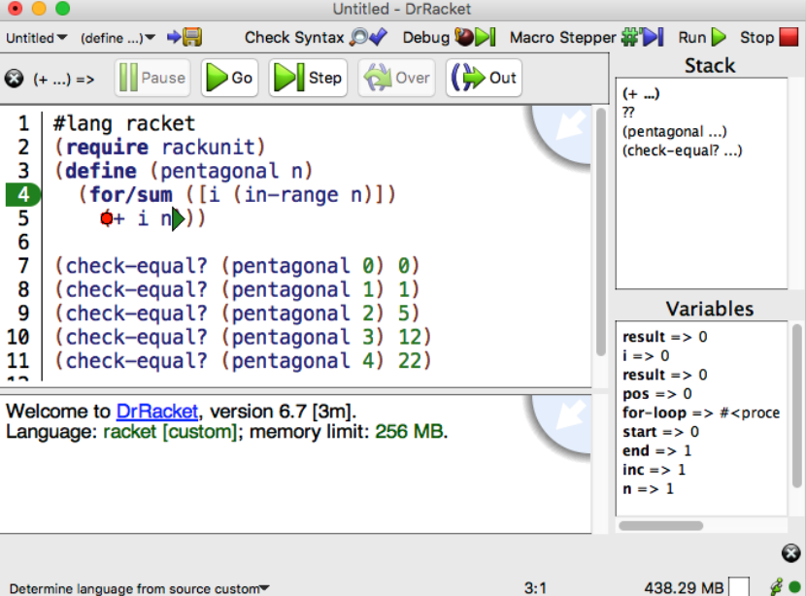

* + The **green triangle** at the end of (+ i n) is where execution is currently paused.
  + **Hovering the mouse cursor over a parenthesis** **may reveal a pink circle.** Right-clicking or control-clicking (Mac OS) will open a menu with options to Pause at this point or Continue to this point.
* The first time it is debugged, breakpoints will only become available in expressions as they are evaluated. From next time, the debugger will remember the set of breakable locations from the previous session.
* **Run** will cause all breakpoints to disappear, but the breakpoints will not be forgotten, and clicking Debug again will restore them.
  + At the start of an expression, then **right-clicking or control-clicking (Mac OS) on the green triangle** opens a menu with the option to Skip expression. A text box will open and accept a value for the expression to be skipped.
  + While execution is paused, the **stack view pane** at the right of the DrRacket frame is active. The top of the pane shows a list of active stack frames. Mousing over a frame prod uces a faint green highlighting of the corresponding expression in the code. The bottom of the pane shows variables in the stack frame.

**In-Lab**

* + some list codes with errors in DrRacket see if they can find it.
  + different and nice features of DrRacket